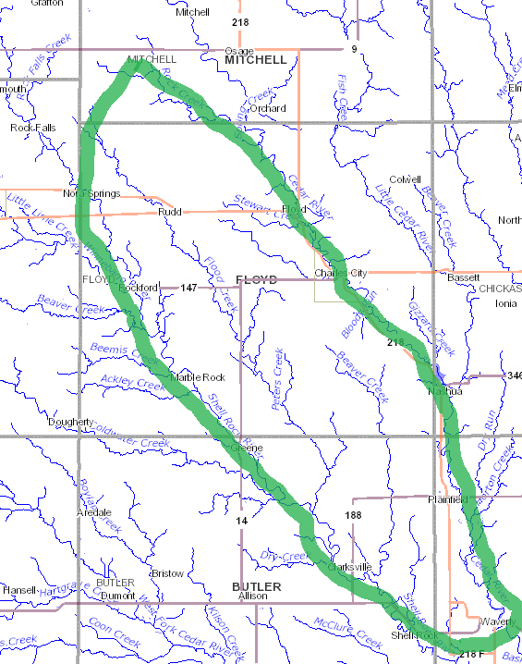
Who is this warning directed to: This message is meant for Public and Private Well owners or users of Source Water, flowing in aquifers downstream from Southwest Mitchell County, Iowa’s, Cedar (W) Township (hereafter referred to as the “Plume”). The boundary of the Plume on an Iowa map is the Shell Rock River on the west and the Cedar River on the east, down to just south of Waverly, Iowa where the two Rivers join to continue on as the Cedar River. In addition to any Private water wells in this area, some of the cities accessing potentially contaminated Source Water in this Plume are Nora Springs, Rudd, Floyd, Rockford, Charles City, Marble Rock, Powersville, Nashua, Greene, Packard, Plainfield, Clarksville, Shell Rock, and Waverly. As such, any residents of the cities within the Plume should also take appropriate action as a result of this warning.
Why you are being contacted: You and/or your neighbors are downstream water consumers of “potentially” contaminated Source Water that is originating further upstream in Mitchell County. Due to a variety of factors that are being researched, several water quality tests performed for upstream users and consumers of the same water supply have come back as contaminated and unfit for either infants or worse.
What you should do to ensure your water is safe right now: AS SOON AS POSSIBLE for Private Well owners, you should contact County Sanitarian, the University of Iowa Hygienic Lab or any other reputable drinking water testing facility to perform various quality tests of your drinking water. For Public well water consumers, please contact your water utility. The EPA requires all community water systems to prepare and deliver an annual consumer confidence report (CCR) (sometimes called a water quality report) for their customers by July 1 of each year.
At a minimum you should request at least these two sets of tests be completed: “Nitrates and Bacteria” (group of tests) and “Ammonia Nitrogen as (N)” (aka Anhydrous Ammonia). These tests should be completed on the same source water from the same sample date. You may choose to run additional tests such as the heavy metals test (tests for lead and other metals in the water), tests for decontaminants, and Atrazine, but those aren’t the specific focus of this notification. There are National Primary Drinking Water Regulations as set forth by the United States EPA. Please go to the EPA’s website for additional information on tests and safe contaminant levels.
http://water.epa.gov/drink/contaminants/
Reading your results: You should familiarize yourself with the Maximum Contaminant Levels (MCLs) as established by the EPA. Depending on which specific tests you have run, you should look for:
- The “Nitrate (as N)” test result should be less than 10 mg/L (or PPM).
- The “Nitrite (as N)” test result should be less than 1 mg/L (or PPM).
- The “Ammonia Nitrogen as (N)” total should be 0.000 mg/L (orPPM)
- If you add together the “Nitrate (as N)” and “Ammonia Nitrogen as (N)” test results, their total should be less than 10 mg/L (or PPM).
- Other test results should be compared against the Maximum Contaminant Limits as established by the EPA.
If your Source Water tests positive (remember positive means the contaminant is present), you should confirm whether it is within the EPA established safe levels as described on their website (an excerpt is shown at the bottom of this document). If any of your levels exceed the MCL (limits established by the EPA), your water is not safe to drink and you need to take appropriate action. Besides the Bacteria from CAFO fertilizer runoff and Chlorine used to kill that contaminant, can develop deadly decontaminants if your source water contains higher levels of Ammonia Nitrogen as (N) test results. Most of the Nitrates and Nitrites usually don’t affect the taste of your source water, this can cause you to assume your water is safe when it isn’t.
Contact the IDNR and EPA for advice before adding Chlorine to Source Water that contains Ammonia Nitrogen as (N) aka Anhydrous Ammonia, to treat Source Water with high Bacteria.
What you should do in the future: It is advised that you retest your water at least twice a year (spring and fall) to ensure it continues to be safe. You should also test after any major rain events (which cause large amounts of contaminants to enter the aquifer). Due to a variety of factors occurring upstream in the aquifer, it is essential that you continue to retest for Nitrates & Bacteria, Ammonia Nitrogen as (N) and any other tests you choose to ensure your water quality continues to be safe for you and your family. You may want to look at another test which is more comprehensive such as the Nitrogen Spectrum Test.
You may want to also contact the Iowa Department of Natural Resources and/or the United States Environmental Protection Agency for additional information regarding the contamination and what is being done about the Point Source Pollution that causes this Plume.

Additional information that may help:
- Maximum Contaminant Level Goal (MCLG) - The level of a contaminant in drinking water below which there is no known or expected risk to health. MCLGs allow for a margin of safety and are non-enforceable public health goals.
- Maximum Contaminant Level (MCL) - The highest level of a contaminant that is allowed in drinking water. MCLs are set as close to MCLGs as feasible using the best available treatment technology and taking cost into consideration. MCLs are enforceable standards.
- Maximum Residual Disinfectant Level Goal (MRDLG) - The level of a drinking water disinfectant below which there is no known or expected risk to health. MRDLGs do not reflect the benefits of the use of disinfectants to control microbial contaminants.)
- Treatment Technique (TT) - A required process intended to reduce the level of a contaminant in drinking water.
- Maximum Residual Disinfectant Level (MRDL) - The highest level of a disinfectant allowed in drinking water. There is convincing evidence that addition of a disinfectant is necessary for control of microbial contaminants.
- Units are in milligrams per liter (mg/L) unless otherwise noted. Milligrams per liter are equivalent to parts per million (PPM).
Contaminant | MCLG¹ (mg/L)² | MCL or TT¹ (mg/L)² | Potential Health Effects from Long-Term Exposure Above the MCL (unless specified as short-term) | Sources of Contaminant in Drinking Water
Lead | zero | TT⁷; Action Level=0.015 | Infants and children: Delays in physical or mental development; children could show slight deficits in attention span and learning abilities  Adults: Kidney problems; high blood pressure | Corrosion of household plumbing systems; erosion of natural deposits
Nitrate (measured as Nitrogen) | 10 | 10 | Infants below the age of six months who drink water containing nitrate in excess of the MCL could become seriously ill and, if untreated, may die. Symptoms include shortness of breath and blue-baby syndrome. | Runoff from fertilizer use; leaking from septic tanks, sewage; erosion of natural deposits
Nitrite (measured as Nitrogen) | 1 | 1 | Infants below the age of six months who drink water containing nitrite in excess of the MCL could become seriously ill and, if untreated, may die. Symptoms include shortness of breath and blue-baby syndrome. | Runoff from fertilizer use; leaking from septic tanks, sewage; erosion of natural deposits
Alachlor | zero | 0.002 | Eye, liver, kidney or spleen problems; anemia; increased risk of cancer | Runoff from herbicide used on row crops
Atrazine | 0.003 | 0.003 | Cardiovascular system or reproductive problems | Runoff from herbicide used on row crops
2,4-D | 0.07 | 0.07 | Kidney, liver, or adrenal gland problems | Runoff from herbicide used on row crops
Dalapon | 0.2 | 0.2 | Minor kidney changes | Runoff from herbicide used on rights of way
1,2-Dibromo-3-chloropropane (DBCP) | zero | 0.0002 | Reproductive difficulties; increased risk of cancer | Runoff/leaching from soil fumigant used on soybeans, cotton, pineapples, and orchards
Dinoseb | 0.007 | 0.007 | Reproductive difficulties | Runoff from herbicide used on soybeans and vegetables
Dioxin (2,3,7,8-TCDD) | zero | 0.00000003 | Reproductive difficulties; increased risk of cancer | Emissions from waste incineration and other combustion; discharge from chemical factories
Diquat | 0.02 | 0.02 | Cataracts | Runoff from herbicide use
Endothall | 0.1 | 0.1 | Stomach and intestinal problems | Runoff from herbicide use
Endrin | 0.002 | 0.002 | Liver problems | Residue of banned insecticide
Epichlorohydrin | zero | TT⁸ | Increased cancer risk, and over a long period of time, stomach problems | Discharge from industrial chemical factories; an impurity of some water treatment chemicals
Glyphosate | 0.7 | 0.7 | Kidney problems; reproductive difficulties | Runoff from herbicide use
Heptachlor | zero | 0.0004 | Liver damage; increased risk of cancer | Residue of banned termiticide
Heptachlor epoxide | zero | 0.0002 | Liver damage; increased risk of cancer | Breakdown of heptachlor
Lindane | 0.0002 | 0.0002 | Liver or kidney problems | Runoff/leaching from insecticide used on cattle, lumber, gardens
Picloram | 0.5 | 0.5 | Liver problems | Herbicide runoff
Simazine | 0.004 | 0.004 | Problems with blood | Herbicide runoff
Styrene | 0.1 | 0.1 | Liver, kidney, or circulatory system problems | Discharge from rubber and plastic factories; leaching from landfills
Tetrachloroethylene | zero | 0.005 | Liver problems; increased risk of cancer | Discharge from factories and dry cleaners
Toluene | 1 | 1 | Nervous system, kidney, or liver problems | Discharge from petroleum factories
Toxaphene | zero | 0.003 | Kidney, liver, or thyroid problems; increased risk of cancer | Runoff/leaching from insecticide used on cotton and cattle
2,4,5-TP (Silvex) | 0.05 | 0.05 | Liver problems | Residue of banned herbicide

